Installing the CUAE Directory Firefox Plugin

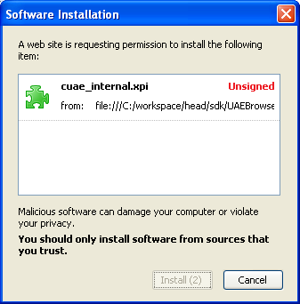
- Go to URL file://///aus-filer01a/published/secall/cuae_internal.xpi from Cisco web.

  - Click ‘Install’ when Firefox/Mozilla prompts.
  - Restart Firefox
- Once Firefox loads, double-click the Cisco icon in the bottom right to bring up the preferences pane.
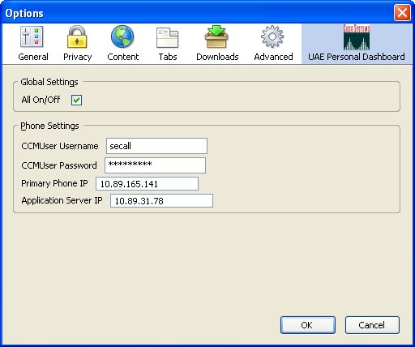

  - Select UAE Personal Dashboard if not already selected.
  - Enter your Cisco username.
  - Enter your CallManager password
    - Your CallManager password is independent of your Cisco UNIX and domain passwords. You can reset it virtually instantly by going to the Call Manager Password Reset Tool at http://phone.cisco.com/ .
  - Enter the IP address of your phone
    - Settings > Network Configuration > IP Address

Using the CUAE Directory Firefox Plugin

Navigate to the Cisco directory, and search for a user.

Next to the Telephone and/or Mobile Phone, there should now be a small telephone icon.

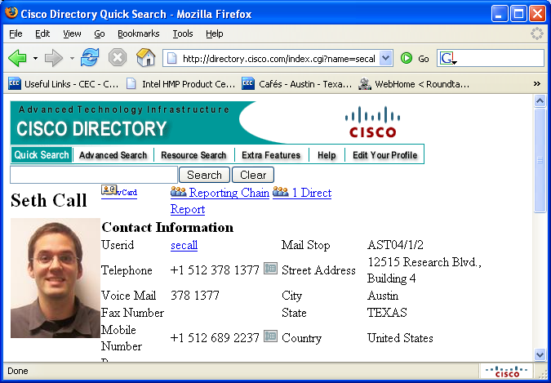

Clicking the phone icon will bring up a dialog box.

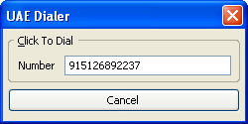

This dialog box will count down from 5 seconds—once it’s complete, your phone will dial the number in the box.

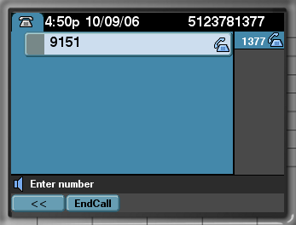

The Cancel button will become a Hangup button, and one can use the dialog to either end their call or cancel it in mid-ring.

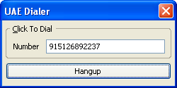

If one hit’s cancel before the 5 second timer has completed, the button will become a Dial button. This gives the user a chance to modify the Number. Pushing Dial will cause a call to be immediately made.

